CS 499 Milestone Two: Enhancement One

Software Design/Engineering

Jennifer Tabor

Southern New Hampshire University

CS 499 Milestone Two: Enhancement One

Software Design/Engineering

Artifact Description

The artifact I am using is an Android note taking application. Upon all the enhancements being added it will allow the user to notate companies they have applied for positions with storing the company information. The application is based on a much simpler application I created in CS 360 Mobile Application Development. Due to trauma to my previous laptop I was unable to retrieve the application that I created in January-February of this year, so I made this new application upon starting this class.

Justification

Using this application will demonstrate all the aspects of the final project for my ePortfolio. I have already equipped it with the SQLite database and will enhance it with the user’s login email and password. I will use data structures and algorithms to add Google Maps and enhancements to the note layout in order to store the company data the user adds. I am demonstrating the aspect of software design/engineering this week by adding the login screen to my application and enhancing the startup of the application by going from successful login to the application start page. The building of the application and additional enhancements will show all the skills I have learned throughout my educational journey.

Module One Objectives

The objectives I mentioned in the code review and the above dialog are different objectives than the ones I outlined in module one because I could not access the applications I wanted to enhance initially. I had to find a way to fulfill all the requirements in a short period of time and developing a new Android application will allow me to do this. By creating a wireframe of the initial application with the planned enhancements along with adding the login screen I am demonstrating software design/engineering skills.

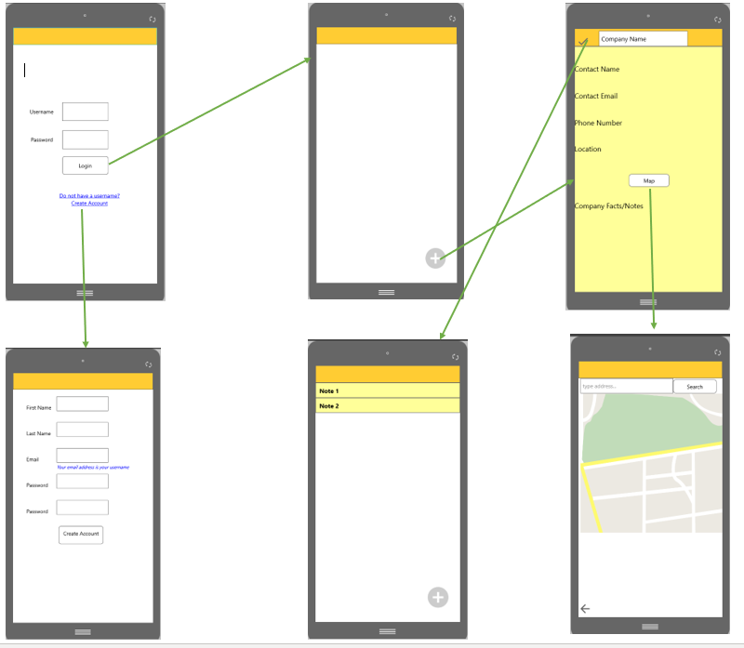

Reflection

I had never added a login activity to an Android app before. All the apps I developed simply launched right into the activity of the app. After adding the login activity, I found that after the AndroidManifest.xml was updated I found that when I ran the app the login page was shown and I could login however, it would basically stop running and give me a “Success” message. I had to figure out how to go to the next activity so that my app could be used to add new notes. This required research. If I learned anything at all during my education, it is that research is a necessary and almost mandatory aspect of programming, developing applications and debugging. While those who have years of applied experience may not get stuck on the little things that I do there is bound to be issues that have never been encountered before. I read many StackOverflow.com posts and numerous blogs to try to figure out what I needed to do to go to the next activity and alas I found the post that made the difference for me at <https://stackoverflow.com/questions/36357493/open-a-new-activity-after-successful-login-android-studio-app>. I gleaned an excerpt that made sense to the code I had in my LoginActivity.java file and added the Intent so that I could start ProfileNotesActivity.java upon successful login. 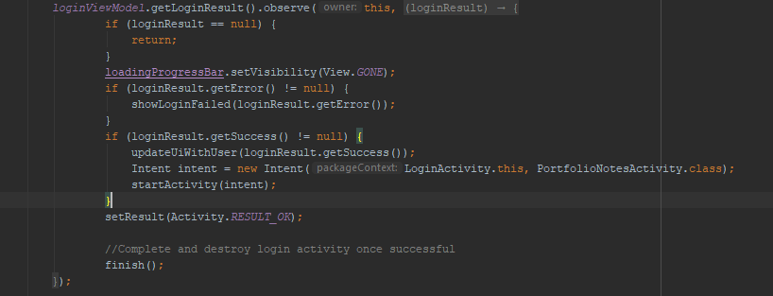

Prior to figuring the above solution I had tried to add Firebase but ran into issues with the implementations being incompatible. I learned a lot about updating the gradle file to AndroidX to handle the issues but was not successful getting it fixed which is why I decided to just add a new Android activity to my package and chose the login activity and modified the code to suit the needs of the application. I am still wanting to add a sign-up activity and hope to do so along with adding the design details to the note taking part of the app and the Google maps activity.

I am also still working on the registration page for the app. The functionality of the login is not what it needs to be yet because the database is not storing and comparing the username and password. Also, there needs to be a link to register. I began this process by making a login demo app that I will also turn in for reference. It is not a working application, but it has the bare bones I want for my login/registration activity. It will mean re-designing the LoginActivity.java and activity_login.xml files. Currently, I have the constraint layout for the login, but I want it to be like the demo I created with a Linear Layout instead, so I am going to be redesigning this today.

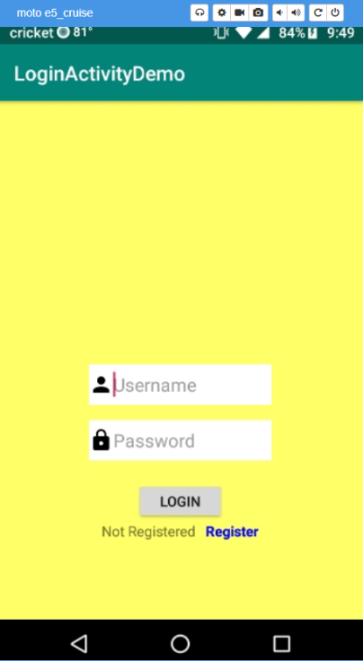The demo looks like this:

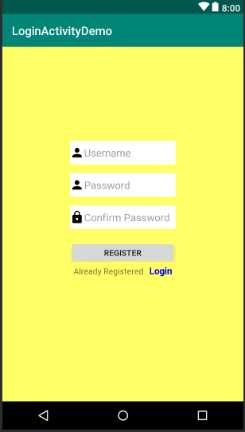

As you can see, this has the language under the login button for those who have not signed up yet. At this point the demo is just a design with some basic programming to acknowledge the activity_register.xml and activity_login.xml files. There is no functionality in the demo, but I am going to add it so that when the “Register” link is clicked it takes the user to the registration page as well as allows registered users to go back to the login page. If I am able to accomplish this before the deadline for the assignment I will re-submit my application but it is a lot of work to take out the current login activity and redo the entire process so I am turning in my app as it is now while I continue to work on it.